Annual bonus Analysis

[https://public.tableau.com/app/profile/charul.mehta/viz/AnnualbonusAnalysis](https://public.tableau.com/app/profile/charul.mehta/viz/AnnualbonusAnalysis_16846483518410/AnnualbonusAnalysis?publish=yes)

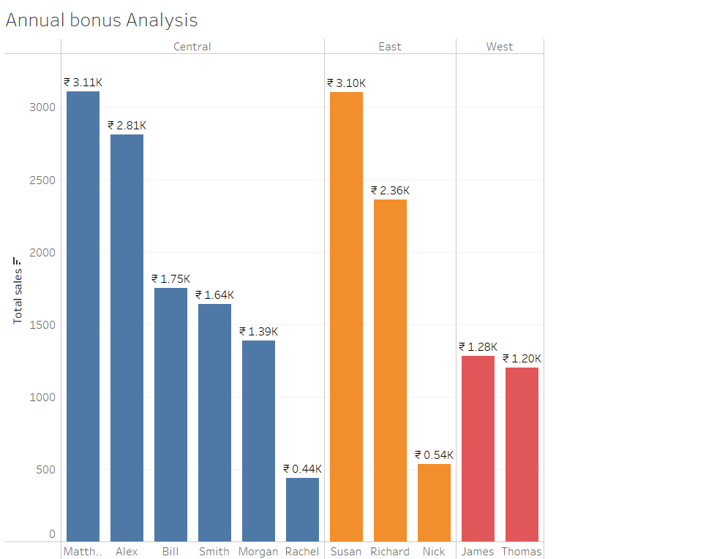

Profit across countries

[https://public.tableau.com/app/profile/charul.mehta/viz/profitacrosscountries](https://public.tableau.com/app/profile/charul.mehta/viz/profitacrosscountries/Profitaccrosscountries?publish=yes)

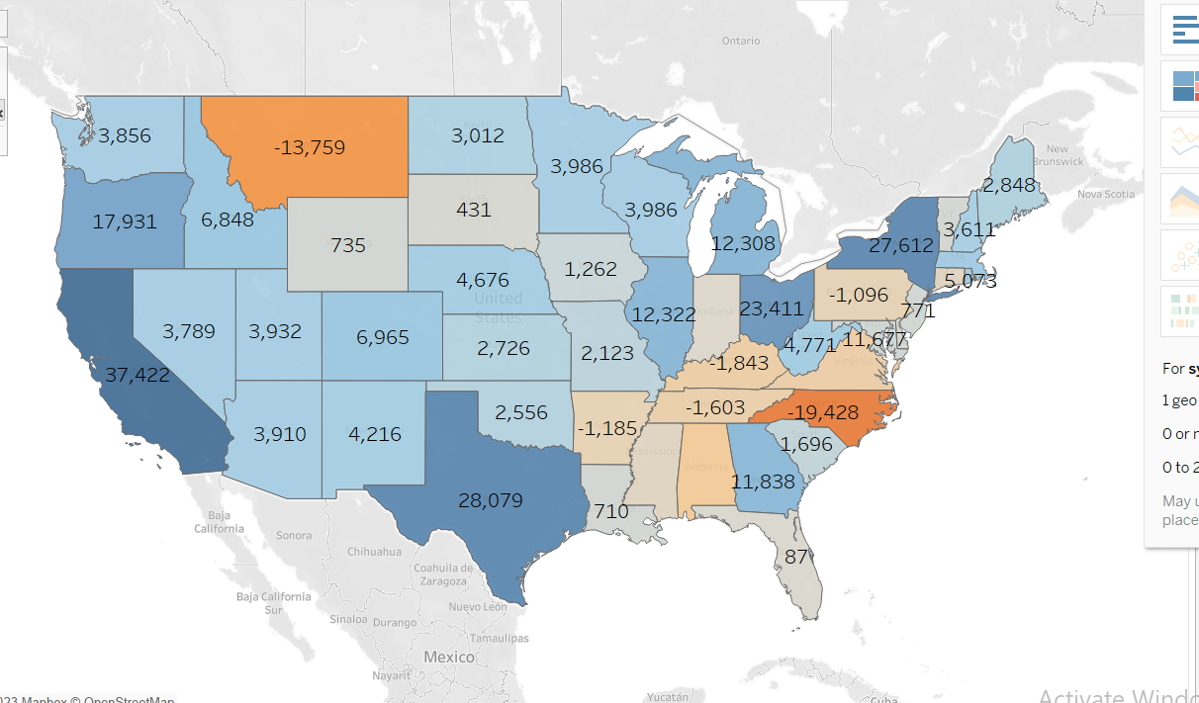

**Unemployment in US from 2005 to 2015**

[https://public.tableau.com/app/profile/charul.mehta/viz/UnemployementinUSfrom2005to2015](https://public.tableau.com/app/profile/charul.mehta/viz/UnemployementinUSfrom2005to2015_16846558833810/Sheet1?publish=yes)

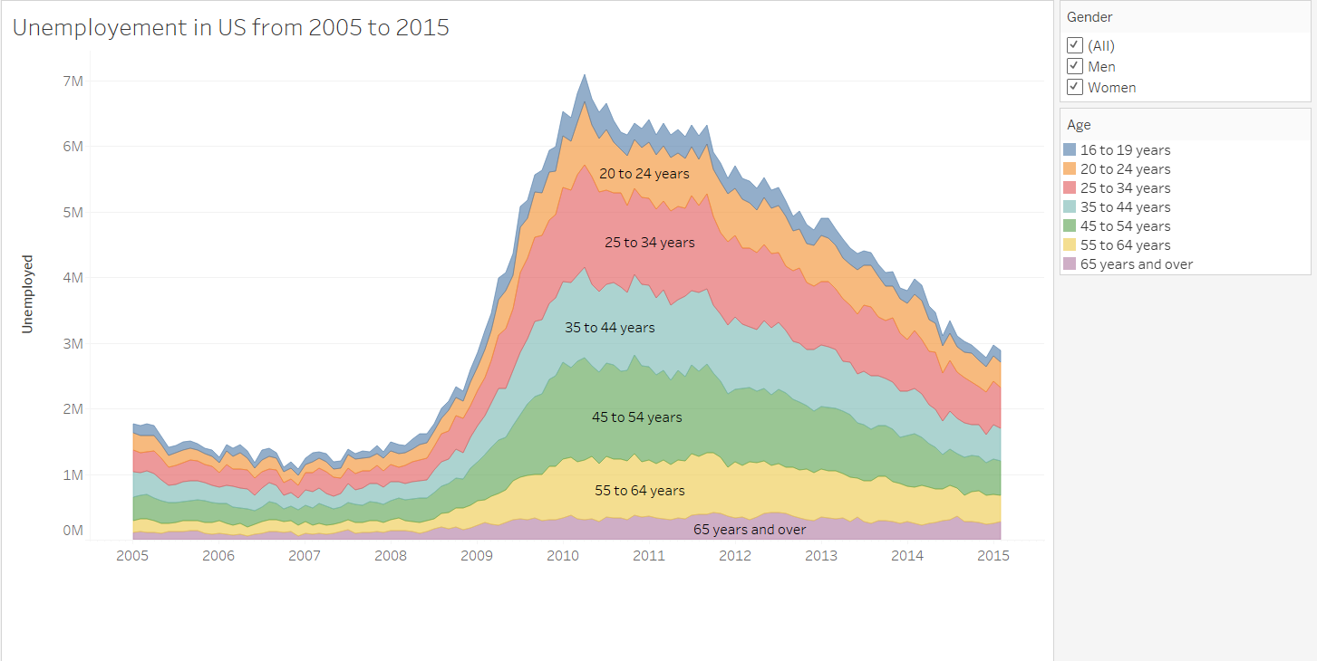

# Dashboard Sales in europe and profit,sales analysis across countries

[https://public.tableau.com/app/profile/charul.mehta/viz/DashboardSalesineuropeandprofitsalesanalysisacrosscountries](https://public.tableau.com/app/profile/charul.mehta/viz/DashboardSalesineuropeandprofitsalesanalysisacrosscountries/Dashboard1?publish=yes)

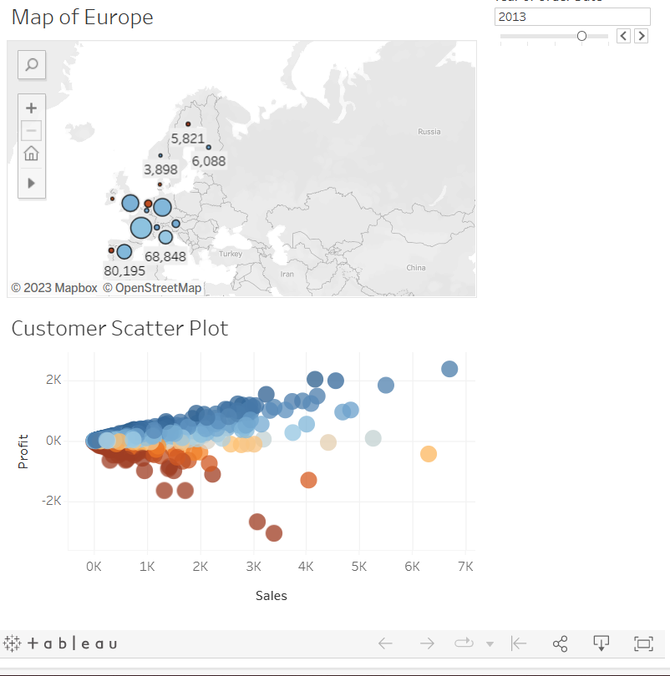

Airlines Revenue Period and Region

[https://public.tableau.com/app/profile/charul.mehta/viz/AirlinesRevenuePeriodandRegion/](https://public.tableau.com/app/profile/charul.mehta/viz/AirlinesRevenuePeriodandRegion/Sheet1?publish=yes)

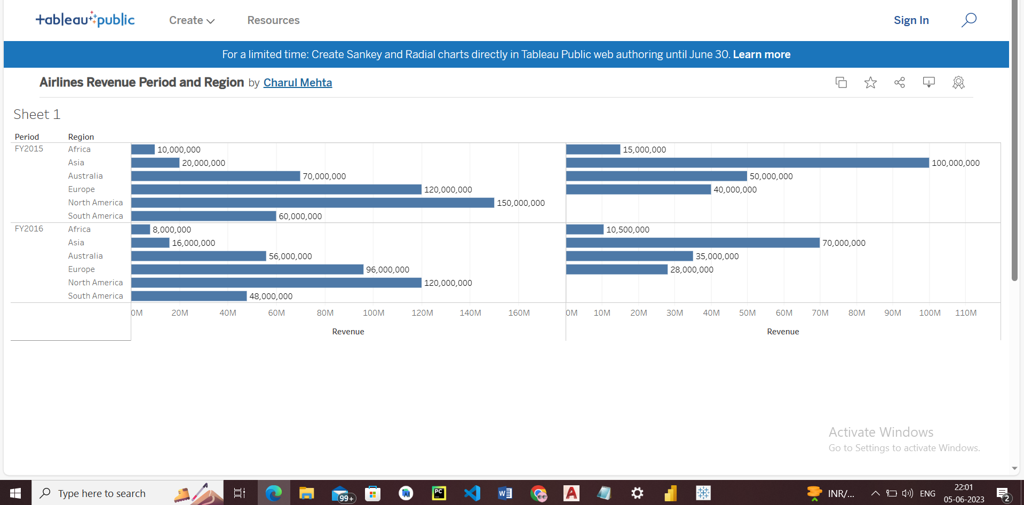

# Dual Axis Chart for Sales and target analysis over category and month

[https://public.tableau.com/app/profile/charul.mehta/viz/DualAxisChartforSalesandtargetanalysisovercategoryandmonth/](https://public.tableau.com/app/profile/charul.mehta/viz/DualAxisChartforSalesandtargetanalysisovercategoryandmonth/Sheet1?publish=yes)

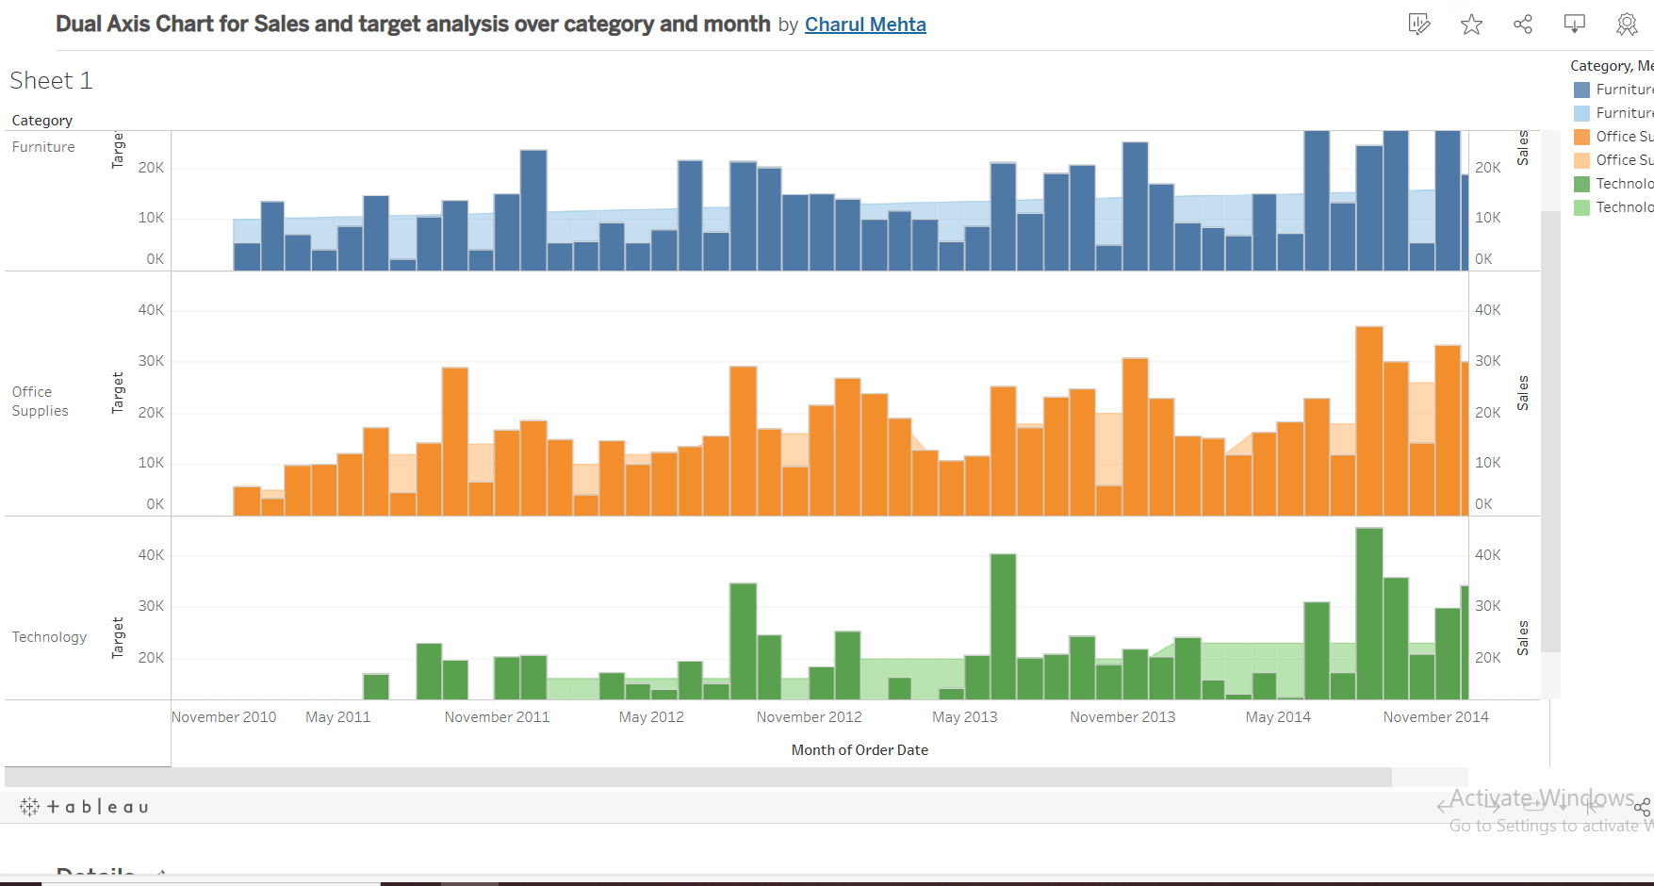

# Version 2:Dual Axis Chart for Sales and target analysis over category and month

[https://public.tableau.com/app/profile/charul.mehta/viz/Version2DualAxisChartforSalesandtargetanalysisovercategoryandmonth/](https://public.tableau.com/app/profile/charul.mehta/viz/Version2DualAxisChartforSalesandtargetanalysisovercategoryandmonth/Sheet1?publish=yes)

